Levi George

02/21/2021

Prof. Amal Khalifa

CS 350: Programming Language Design

Homework 3: Ruby and Variables

1. What is the syntax for declaring a variable of a given type?
   1. **Ruby uses weakly typed variables, so you don’t need much to declare a variable in a specific type. It is a simple declaration; you name your variable then give it your desired value. This will automatically allocate the appropriate space.**
   2. 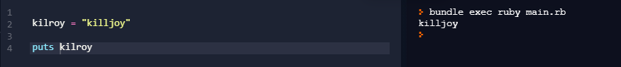
2. List at least three primitive data types along with their range of values.
   1. **Char – 1 byte or 8 bits long**
   2. **Integer (positive and negative whole numbers) – 4 bytes or 32 bits**
   3. **Doubles – 8 bytes or 64 bits**
   4. I actually used a specific method of getting the size of each data type from the compiler.
   5. 